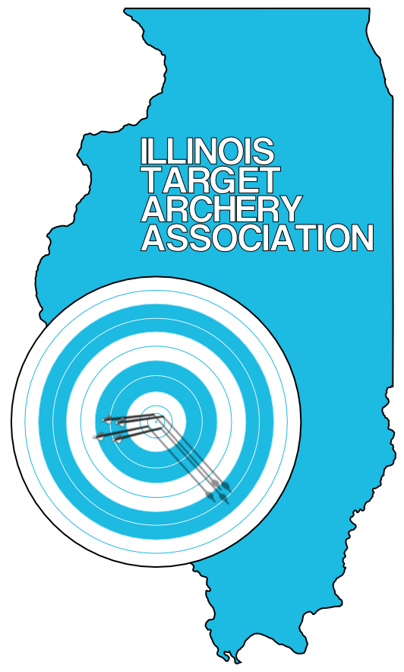
ILLINOIS TARGET ARCHERY ASSOCIATION
AUGUST 9, 10, & 11, 2013
ITAA OUTDOOR STATE CHAMPIONSHIP – 900 METRIC ROUND
The 2012 Illinois Target Archery Association Outdoor State Championship will be held this year at the Wheaton Rifle Club on the weekend of August 9th through 11th. This year’s tournament will be a sanctioned “STAR FITA” event. Bow styles and age divisions will all comply with USA Archery guidelines.

Schedule:

Friday, August 9th: Novice Open State Championship 450 Metric Round. This portion of the tournament is for archers of any age who have just recently taken up the sport of archery. It is intended to introduce tournament style shooting conditions to people participating in their first or second tournament. The format will be a 450 Metric Round. 5:00 PM check in and practice. 6:00 PM scoring begins. There will be 15 arrows shot at 15M, 12 M, and 10M for a total of forty-five scored arrows. The 122cm FITA target face will be used at all distances. Every participant will receive a participation medal.

Saturday, August 10th: Bowman State Championship 900 Metric Round. 8:00 AM check in and practice. 9:00 AM scoring begins. The format for bowman will be thirty arrows each at 30M, 25M and 20M. The 122cm FITA target face will be used at all distances.

Saturday, August 10th: Cub, and Cadet State Championship 900 Metric Round. 1:00 PM check in and practice. 2:00 PM scoring begins. The format for cubs and cadets will be thirty arrows each at 40M, 30M and 20M for a total of ninety scored arrows. The 122cm FITA Face will be used at all distances.

Sunday, August 11th: Junior, Senior, and Master State Championship 900 Metric Round. There will be two shooting lines to choose from.
Morning: 8:00 AM check in and practice. 9:00 AM scoring begins. Afternoon: 1:00 PM check in and practice. 2:00 PM scoring begins. The format will be thirty arrows each at 60M, 50M and 40M for a total of ninety scored arrows. The 122cm FITA target face will be used at all distances. Cadets may choose to shoot these distances, but should register and compete as Juniors.

Pre-registration and Tournament Fee: Registration is required in advance since each shooting line can only accommodate a total of twenty-eight archers. Registration can be done online at www.illinoistargetarchery.org Deadline for registration is August 8th to guarantee your spot on the shooting line. The Saturday and Sunday state championship tournament fee is $25 for adults, $20 for youth. The Friday evening novice event is $15. There is a family maximum fee of $50. ITAA shoots are open to any interested participants, regardless of NAA/NFAA/IBO affiliation. Non-members and non-Illinois residents may also participate.

Equipment Inspection: All equipment will be inspected at the time of registration prior to each shooting line. In particular, poundage and arrow shaft size must comply with FITA World Archery guidelines. The USA Archery dress code will not be enforced.

Additional Shooting Times: In the case that shooting lines fill up, the following times will be added. If the Saturday afternoon line fills up, Cubs and Cadets will join Bowmen Saturday morning. If the Sunday adult lines fill up, an additional shooting line will be added Saturday evening.
ITAA Membership Meeting: The ITAA will hold a general membership meeting, beginning approximately at 5:00 PM on Sunday. The agenda will not exceed 30 minutes. Anyone can attend the meeting. If issues come to vote, voters must be 18 years of age, an Illinois resident, and hold USA Archery member status.
Location and Accomodations: The Wheaton Rifle Club is located at: 27W070 North Ave., West Chicago, Illinois. It is on the north side of North Ave (Rt. 64), four buildings east of County Farm Road. Concession food and beverage items, including lunch, will be available for purchase.
Awards: State Championship Medals will be awarded for first, second, and third place in each division. All participants in the Friday evening novice shoot will receive a participation medal.
Additional Information: Tom Havel at tbhavel@comcast.net

